User Story
Use case Diagram
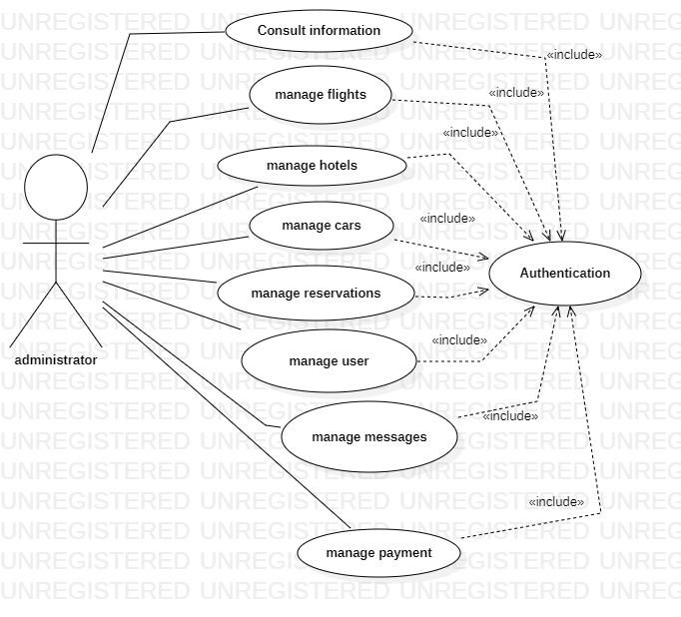
Use Diagram on Administrator Side

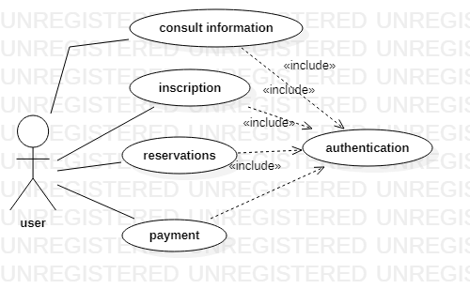
Use Diagram Customer

Classes Diagram

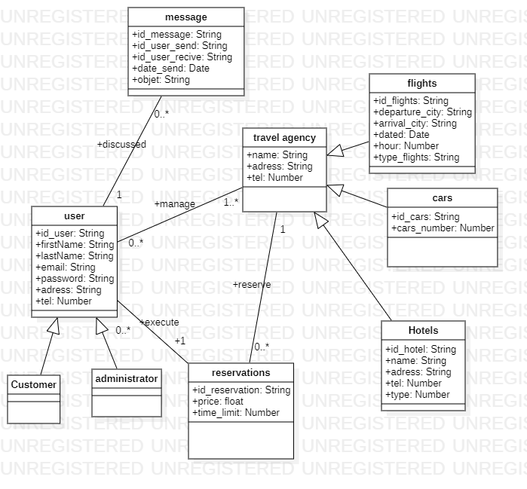
Class Diagram

